Retail Reward Application:

Build:

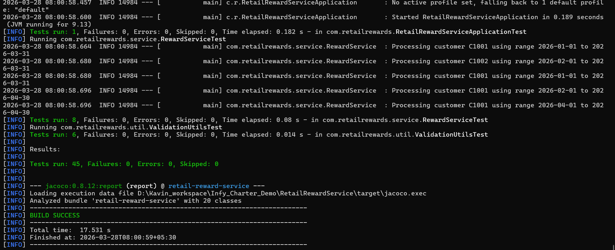

Run:

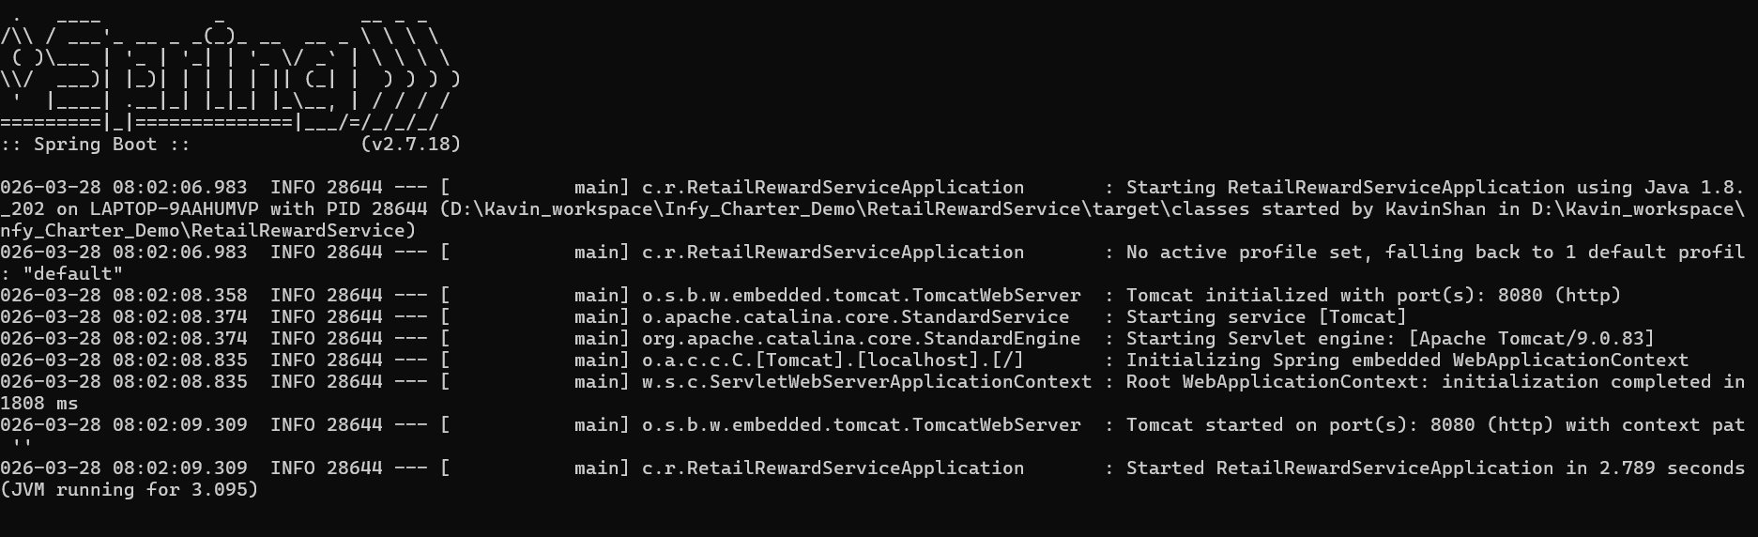

apiUrl: http://localhost:8080/api/v1/rewards/customers
HTTP method: GET

Positive Flow:
Case 1:
Request : customerId
Response : Customer reward points for 3 months
Result : Success
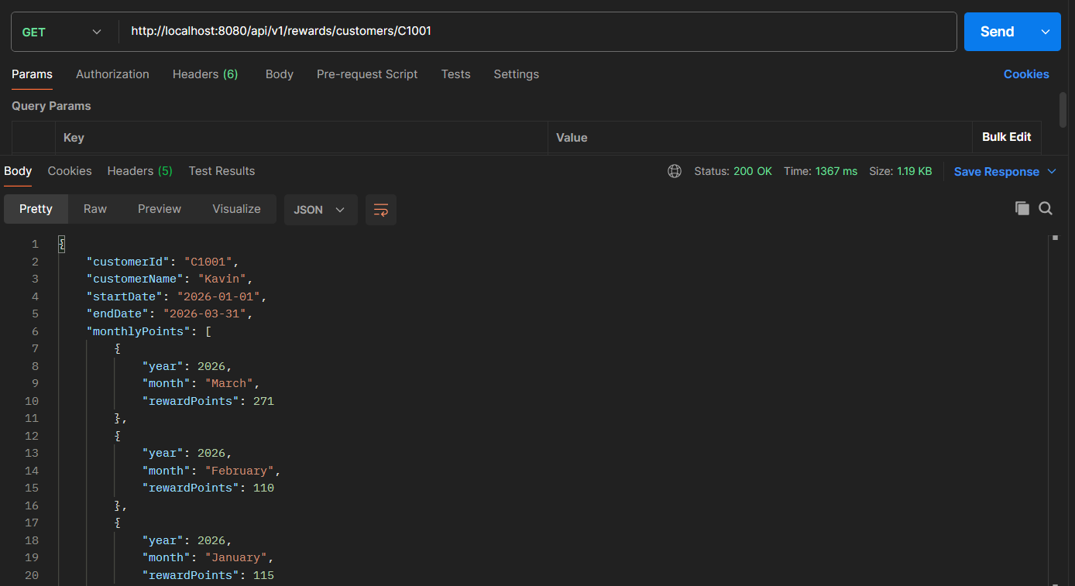

Case 2:
Request : customerId and months
Response : Customer reward points for given months
Result : Success
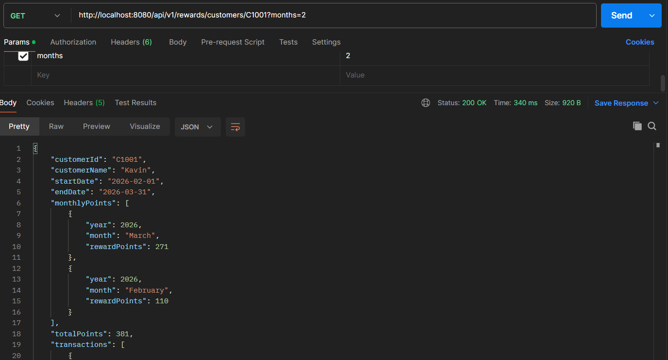

Case 3:
Request : customerId and date range
Response : Customer reward points for given date range
Result : Success
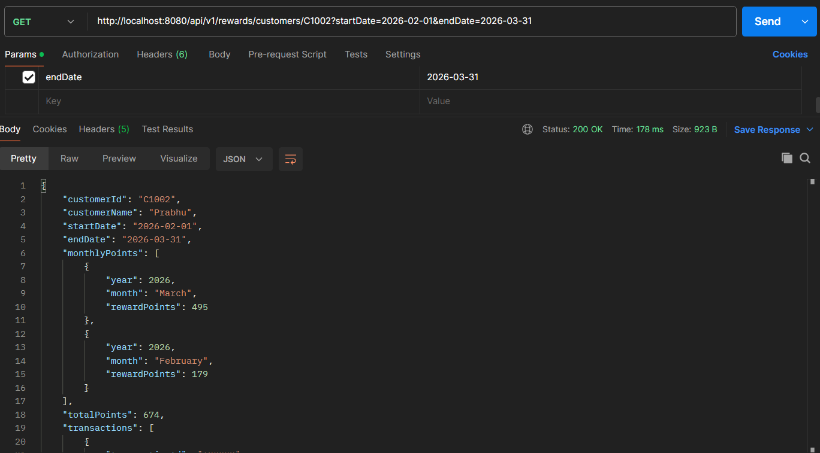

Case 4:
Request : customerId and date range (Only start or end date)
Response : Customer reward points for 3months from start or end date
Result : Success
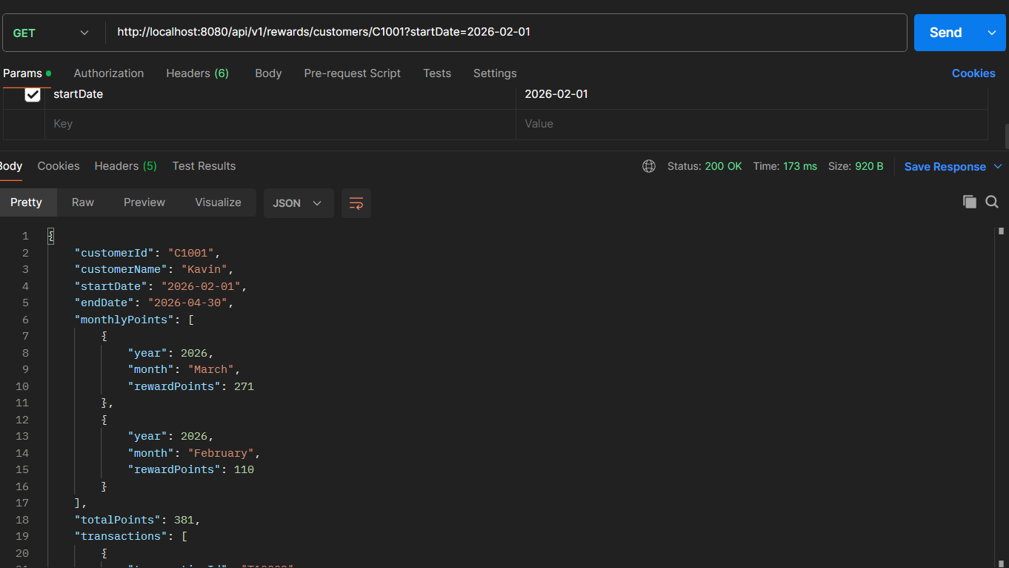

Case 5:
Request : customerId and date range (no transaction for the customer)
Response : Empty response
Result : Success
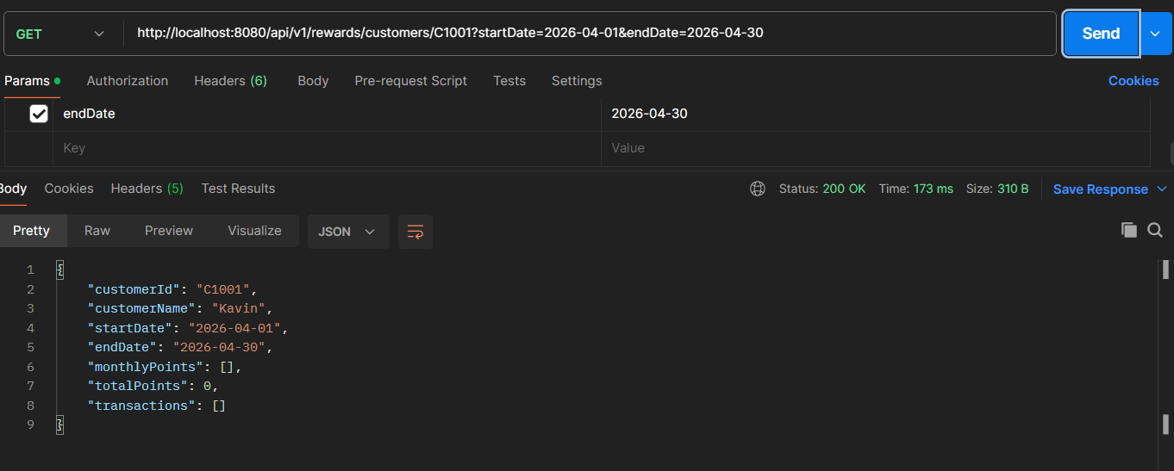

Negative Flow:
Case 1:
Request : invalid customerId
Response : Error response
Result : Success
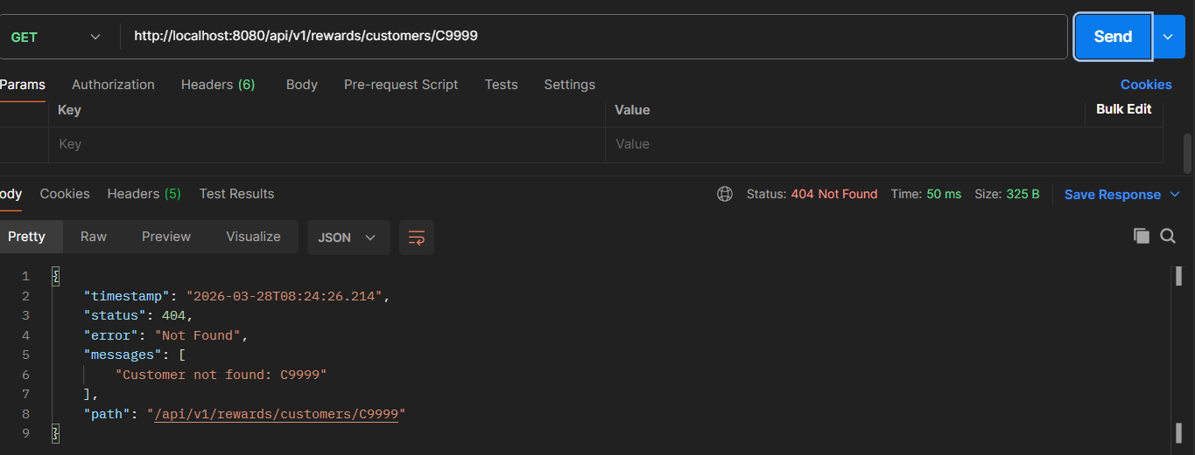
Case 2:
Request : invalid month
Response : Error response
Result : Success
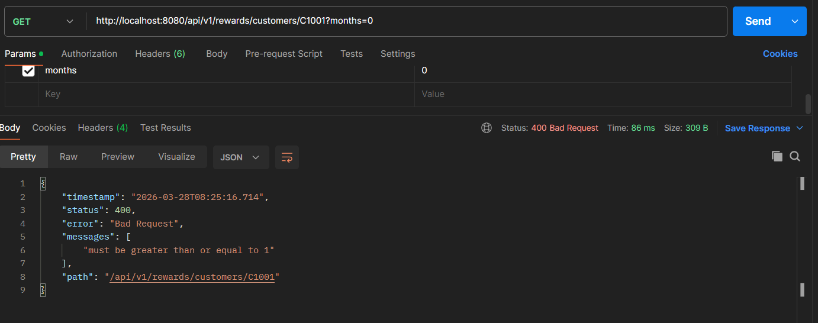
Case 3:
Request : invalid date range
Response : Error response
Result : Success
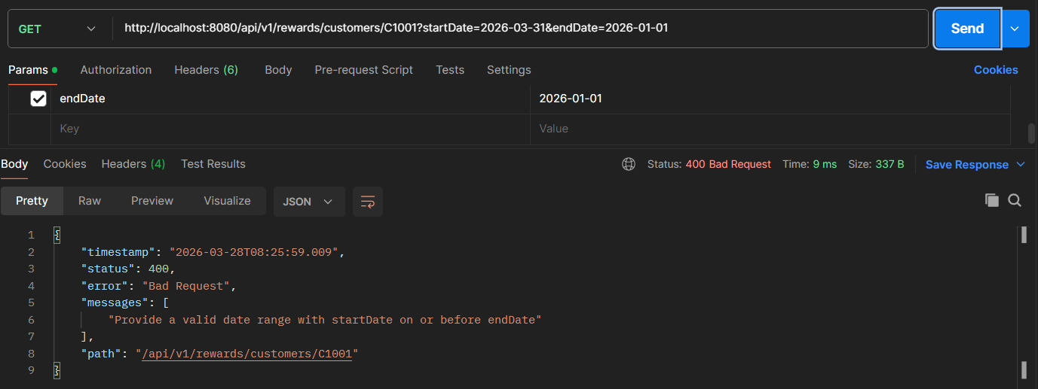
Case 4:
Request : invalid date range
Response : Error response
Result : Success
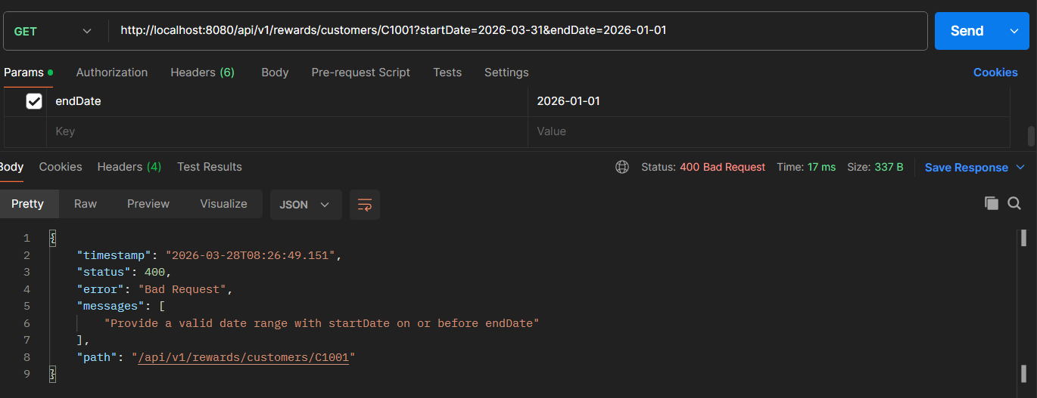

Case 5:
Request : invalid date format
Response : Error response
Result : Success
